<http://ulstercountyny.gov/ulsterforbusiness/guide/>

Change **It’s time**

**for better**

**business** to:

**Learn more about doing business in Ulster County**

(no change on subhead copy)

<http://ulstercountyny.gov/ulsterforbusiness/events>

Upcoming Events

Add text and link:

News and information about Ulster County events:

<https://ulstercountyalive.com/calendar>

<http://ulstercountyny.gov/ulsterforbusiness/growth-industries>

New subhead on photos (title stays same):

**Manufacturing, craft foods & beverages, technology and filmmaking are vibrant and strong.**

Intro text and Video stay as is; change text below video to:

[**Manufacturing/Craft Food & Beverage**](http://ulstercountyny.gov/ulsterforbusiness/food-beverage) - Ulster County manufacturers (large scale and niche) and food/beverage purveyors have easy access to global markets with low costs of doing business and an emphasis on environmental integrity.

[**Technology**](http://ulstercountyny.gov/ulsterforbusiness/technology) - Ulster County small tech firms and digital media companies benefit from low overhead and an outstanding quality of life.

[**Filmmaking**](http://ulstercountyny.gov/ulsterforbusiness/filmmaking) - With tax credits of up to 45%, incredible local talent, and diverse shooting locations, Ulster County is the place to be for film and T.V.

<http://ulstercountyny.gov/ulsterforbusiness/food-beverage>

Add 1-2 more photos to top – Lite Brite Neon and/or Markertek (if both, place one on either side of bread & butter)

Change nav button and page title to:

Manufacturers/Craft Food & Beverage

Change subhead:

Ulster County manufacturers (large scale and niche) and food/beverage purveyors have easy access to global markets with low costs of doing business and an emphasis on environmental integrity.

Add these buttons to the top of the page above the other 3:



**PER SQUARE FOOT:**

**MANHATTAN**

Average price per square foot of office space in Manhattan: $72.



**PER SQUARE FOOT:**

**ULSTER COUNTY**

Average price per square foot for office space in Ulster County: $11.08.



**90 MINUTES**

**FROM NYC**

Ulster County is only 90 minutes from New York City. With direct buses, nearby Amtrak and MetroNorth train service, and the N.Y.S. Thruway, getting here couldn’t be easier.

New text:

Ulster County is known historically as New York City’s breadbasket—and has long been known as a hub for manufacturing—because our diverse businesses have easy access to statewide, national and global markets without the high real estate and labor costs.

Whether you are looking for farmland or factory space, Ulster County has a wide variety of affordable options. More than 500 Ulster County farms supply high-quality, local produce to more than [50 food and beverage manufacturers](http://ulstercountyny.gov/news/business-services-economic-development-executive-press-releases/ulster-county-executive-mike-2) who, in turn, enjoy the support of a community that values local food.

Niche manufacturers and food and beverage makers benefit from services provided by the Ulster County Office of Economic Development, such as:

* [Site assistance](https://ulstercountyny.gov/ulsterforbusiness/find-a-site)
* [Low-interest loans](https://ulstercountyny.gov/ulsterforbusiness/funding)
* [Hands-on business counseling](https://ulstercountyny.gov/ulsterforbusiness/business-coaching)
* [Networking and introductions](https://ulstercountyny.gov/ulsterforbusiness/business-coaching)

• [Creative funding strategies](https://ulstercountyny.gov/ulsterforbusiness/funding)

Add these videos following text:

**Ulster County Welcomes Niche Manufacturers!** Small manufacturing is thriving here in Ulster County, thanks to the support and resources offered by the Ulster County Office of Economic Development. Four diverse niche manufacturers talk about why Ulster County is the best place for their businesses to gain strength, expand and succeed.

**Taste of Craft Beverages**

Needs text underneath like others – does it exist? Also, I notice it is not on the UFB YouTube page either…

**Living in Ulster County: Garnet Heraman & Karina Cousineau Testimonial.** Garnet Heraman & Karina Cousineau talk about how Ulster County is a great place to live and launch a fashion-related manufacturing business in Phoenicia, N.Y., with a retail storefront in Uptown Kingston.

**Profiles** (as is for now but more will be added – perhaps Markertek, Lite Brite Neon, Quercus, etc.)

This could also be included here (can you please save it somewhere in case we decide to revive and revise?):

[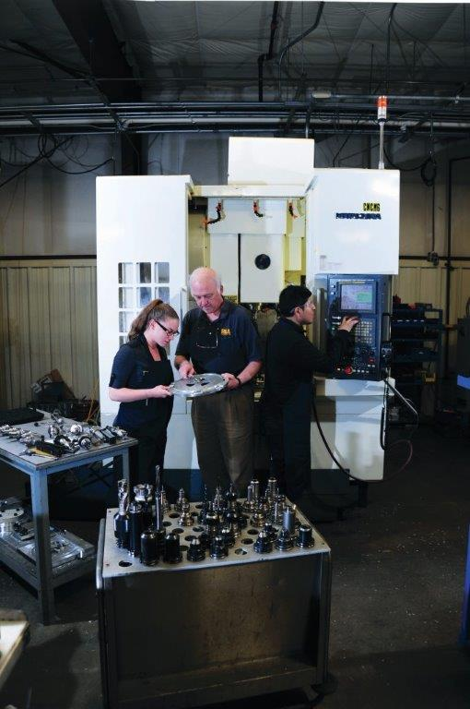](http://www.falatech.com/page.asp?pageid=2)

[**Fala Technologies**](http://www.falatech.com/page.asp?pageid=2)

Fala Technologies designs and builds innovative components for a variety of high-tech applications, from the electric car to next-generation helicopters. Global-scale manufacturers look to Fala for its expertise and demonstrated capability. Recently, owner Frank Falatyn has been working with Kingston High School to design programming classes that will train the local workforce for next-generation careers in advanced manufacturing.

<http://ulstercountyny.gov/ulsterforbusiness/technology>

Change nav button to Technology

Change text on subhead to:

**Technology**

**Ulster County’s small tech firms and digital media companies benefit from low overhead and an outstanding quality of life.**

**Image buttons stay as is.**

**Text stays as is:**

While Ulster County has long been attractive for manufacturers, it is now a hub for small tech and digital media businesses too. With millions of square feet of both office and industrial space available at a fraction of New York City prices, Ulster County’s designers, makers and entrepreneurs have a significant competitive advantage: lower overhead. Many in the tech industry choose Ulster County for its natural beauty and quality of life. Only 90 minutes from New York City, Ulster County residents and businesses still benefit from easy access to one of the largest markets—for customers AND for talent—on the planet.

Feature these four videos after statistic buttons and text at the top of the page (and move Niche Manufacturers off this page):

Descriptive text as below should be entered under each video:

**Do Business Differently in Ulster County** Less than 100 miles from midtown Manhattan, in Ulster County, New York, tech industry leaders are discovering new ways to successfully manage their businesses, raise their families and enjoy a better quality of life—all at a lower cost of living.

**Living In Ulster County - The Tech Community** Ulster County is a vibrant tech center just 100 miles north of New York City. A robust community of interactive professionals meets regularly in the beautiful and historic Stockade District of Kingston, N.Y.

**Living in Ulster County - Dennis Crowley Testimonial** Dennis Crowley of Foursquare talks about how Ulster County and New York City are connected via just a quick ride on the N.Y.S. Thruway. After a brief period of settling in and establishing himself, he now enjoys easy connectivity with other entrepreneurs in the tech industry in the same vicinity.

**Living in Ulster County: Norm Magnusson Testimonial.** Norm Magnusson, a freelance creative director, talks about how Ulster County offers the best of both worlds: 'wilderness' within easy reach and quick accessibility to N.Y.C. He enjoys abundant opportunities to network with creatives and technologists right here in Ulster County.

**Profiles**

Delete Fala—but save please in case we want to move photo/text to Manufacturing page.

Add title, link, photo and text for Dragon360 in that spot:

<https://www.dragon360.com>

Text:

Since 2007, Dragon360 has provided digital marketing services to organizations in a wide range of verticals and industries nationwide. With a Manhattan office and its main production site in uptown Kingston’s historic Senate Garage Building, Dragon360 has grown dramatically as several of its clients have developed into industry leaders. The Dragon360 team provides integrated digital marketing services that combine digital advertising, search engine optimization, social media marketing and content marketing with proven strategies designed to achieve measurable results. A true digital partner, Dragon360 looks beyond tactics and "digital silos" to focus on the bigger picture: a 360-degree view of its clients’ customers.

Leave HVTM as is.

There will be approximately four more featured profiles on this page (Exago, Markertek/Tower Industries, Cere, Ametek Rotron to be developed – do you have any photos of these?)

<http://ulstercountyny.gov/ulsterforbusiness/filmmaking>

On subheading, make Contact Us button go to <http://ulsterforfilm.com> page (NOT to Contact form at bottom of the page)

Switch positions of right column features: Move Stockade Works into top right and move B.C.D.F. to bottom right.

<http://ulstercountyny.gov/ulsterforbusiness/cities>

The Hudson River Communities

**Saugerties, Kingston, Marlborough, Lloyd, ~~Highland,~~ Esopus, Hurley, Ulster**

The Hudson River, one of the world’s most iconic waterways, creates Ulster County’s eastern border. Since Henry Hudson’s first exploration in 1609, the Hudson River has been a locus of American innovation: It played a pivotal role in the early colonies’ fight for independence, fueled the nation’s westward expansion and gave birth to both the Hudson River School of American art and, thanks to the efforts of such luminaries as Pete Seeger and Robert Kennedy Jr., the modern environmental movement. Today, Ulster County’s riverside communities are revitalized as more and more people join them. Kingston, the historic heart of Ulster County, is brimming with creative energy. It is home to artists and entrepreneurs, and is quickly becoming a hub for the Hudson Valley’s tech industry. Saugerties is an old mill town with beautiful industrial architecture and a vibrant, eclectic arts scene. Farther south, the Town of Lloyd in Highland is the entry point for many coming to Ulster County from the east. Sitting at one end of the Walkway Over the Hudson, it attracts millions of visitors every year. Marlborough is a charming small town surrounded by verdant, rolling hills, acres of farmland and orchards, and several exceptional wineries. The Town of Ulster is known as the “Business Hub” of the county, though it’s also characterized by several quiet hamlets and residential neighborhoods. To the south and west, respectively, of Kingston, the Towns of Esopus and Hurley offer outdoor recreation, historic attractions and a number of picturesque neighborhoods, hamlets and villages within their borders.